

C:\Users\bishop9375\AppData\Local\Microsoft\Windows\Temporary Internet Files\Content.IE5\M8EV269N\MC900309844[1].wmf

***Associated with the Community of Imam W. Deen Mohammed***

August, 2014

***Conveners of Imams:***

**National/Midwest Section:**

**Imam Bashir Ali**

[mecacenter@yahoo.com](mailto:mecacenter@yahoo.com)

309-208-2847

**New England Section:**

**Imam Taalib J. Mahdee**

[tmahdeeone@gmail.com](mailto:tmahdeeone@gmail.com)

617-272-5554

**Northeast Section:**

**Imam Mubaashir Uqdah**

[Mubaashir.uqdah@verizon.net](mailto:Mubaashir.uqdah@verizon.net)

610-597-4033

**Mid-Atlantic Section:**

**Imam Dr. Abdel Nuriddin**

[nuriddin@triadbiz.rr.com](mailto:nuriddin@triadbiz.rr.com)

336-324-9746

**Southern Section:**

**Imam Yahya Islam**

[yaiplumbing@yahoo.com](mailto:yaiplumbing@yahoo.com)

706-442-2895

**Southwest Section:**

**Imam Fahmee Sabree**

[fmsabree@yahoo.com](mailto:fmsabree@yahoo.com)

225-229-9504

**Western Section:**

**Imam Wali Fardan**

[Wali.fardan@cox.com](mailto:Wali.fardan@cox.com)

619-972-3544

***Visit us at:***

***iwdmcommunity.com***

**Statement on the Deaths of African-American Men at the Hands of Police…and by Other African Americans**

[](http://corpus.quran.com/wordbyword.jsp?chapter=7&verse=181#(7:181:1)) [](http://corpus.quran.com/wordbyword.jsp?chapter=7&verse=182#(7:182:1))

***And among those We created is a community/nation which guides by truth and thereby establishes justice. But those that deny Our signs, We will gradually visit with punishment, in ways they perceive not. (Al-Quran 7:181-182)***

[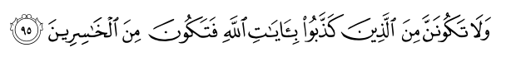](http://corpus.quran.com/wordbyword.jsp?chapter=10&verse=95#(10:95:1))

***And never be of those who deny the signs of Allah and thus be among the losers. (Al-Quran 10:95)***

[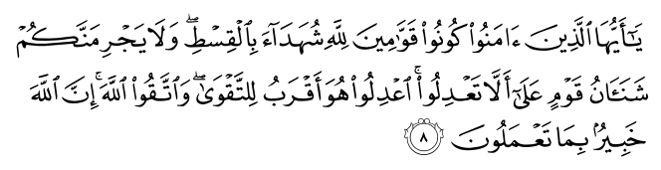](http://corpus.quran.com/wordbyword.jsp?chapter=5&verse=8#(5:8:1))

***O you who believe, stand out firmly for Allah, as witnesses to fair dealing, and let not the hatred of others prevent you from being just. Be just, that is nearer to piety and reverence and respect Allah, for Allah is well-acquainted with all that you do. (Al-Quran 5:8)***

*“We hold these truths to be self-evident that all men are created equal, that they are endowed by their Creator with certain unalienable Rights, that among these are Life, Liberty, and the pursuit of Happiness.—That to secure these rights, Governments are instituted among Men,…” (The Declaration of Independence, July 4,1776)*

* *August 9, 2014: Michael Brown, Age 18, Ferguson, Missouri*
* *August 5, 2014: John Crawford III, Age 22, Beavercreek, Ohio*
* *July 17, 2014: Eric Garner, age 43, Staten Island, New York*
* *September 14, 2013: Jonathan Ferrell, age 24, Charlotte, North Carolina*
* *February 26, 2012: Travon Martin, age 17, Sandford, Florida*

**The Conveners of Imams associated with the Community of Imam W. Deen Mohammed** wish to express our heartfelt sympathy to all the families and loved ones of individuals whose lives have been violently cut short at the hands of law enforcement. This includes the most recent unarmed shooting victim, 18 year old Michael Brown of Ferguson, Missouri.

The tragic death of Michael Brown is the most recent clear-cut case of an unarmed African American man dying at the hands of police. To further add insult to injury, in the aftermath of his death, local law enforcement officials continued to disrespect the needs and sensitivities of his family and community. These, however, are SIGNS of a much deeper phenomenon associated with a long history of racial disparity and insensitivity from law enforcement in America.

America was founded on the ideal, principle, and right of equality before the law of every “man.” This includes the obligation of the government to secure the *“unalienable Rights of Life, Liberty, and the pursuit of Happiness”* of all of its citizens, policeman as well as young men.Unfortunately, the history and reality of the African-American experience has been the exception to this ideal. Part of America’s historic challenge has been an evolving struggle to define and redefine the concept of “men.” Our experience has resulted in two standards of justice: one for the poor and “racial minorities” and another for those with wealth and power, which usually are the “racial majority.”

The African American experience with the “Criminal Justice System” has now reached epidemic proportions! Recent studies conclude:

* In 2012, 313 African Americans were killed by police, security guards, and self-appointed law enforcers, about one every 28 hours *(Operation Ghetto Storm)*
* Of the 313 African Americans killed in 2012, 136 or 44% had no weapon *(Operation Ghetto Storm)*
* African Americans are about 14% of the United States population but constitute about 43% of the incarcerated population *(BlackDemographics.com* and *NAACP Criminal Justice Fact Sheet)*
* By age 23, 49% of Black males have been arrested *(The Wall Street Journal* and the journal: *Crime and Delinquency)*

These numbers are only the tip of the iceberg relative to the disparate impact of both crime and punishment on the African American community. Almost every adult African American male can tell a personal story of a negative encounter with law enforcement. We also know these statistics represent real people connected to real families, loved ones, and communities.

As Muslims, we are most conscious of the Qur’anic guidance and criteria relative to the role of communities and nations to establish justice for all. As Americans, we are reflective of the founding principles of our Declaration of Independence and Constitution establishing one standard of justice for all citizens. However, when the reality of dual systems of justice conflicts with the ideal and rights of equality before the law, the citizens of the society must close the gap between the *conceptual ideal* and the *brutal reality*. As a result, we must hold our government and ourselves responsible for the necessary changes.

The problem exists in at least two forms: 1) the official governing structures of justice and law enforcement at the local, state, and national levels; and 2) the natural institutions of African American community life including our family structures, culture, economic and education systems.

The institution of democracy in America requires its citizens to hold their elected officials accountable to conform to the principles and Constitutional rights afforded them. Therefore, citizens must actively engage at all levels of government (local, state and federal) to ensure this fidelity. While picketing, protesting and exercising our first amendment right is always an outlet and option, gaining real political power involves proactive, sustained, and committed effort. We must be informed on the issues; organize and advocate for an agenda; invest in our agenda; vote and get others to vote consistently; participate as community volunteers and elected officials; and communicate with and hold our elected officials accountable.

In addition to government, perhaps the larger and more fundamental challenge for African Americans will be to examine ourselves and develop the other institutions that support community life. This is essential in addressing the myriad of historical and current threats facing our community.

In one area alone, African Americans experience an average of about 6,300 homicides each year at the hands of other African Americans! This statistic represents a 20 to 1 ratio compared to killings at the hands of police!

[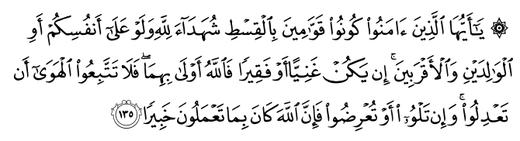](http://corpus.quran.com/wordbyword.jsp?chapter=4&verse=135#(4:135:1))

***O you who believe, stand out firmly for justice, as witnesses to Allah, even as against yourselves, or your parents, or your kin, and whether it be a one who is rich or poor; for Allah is nearer to both of them. So follow not your own desires, lest you deviate; and if you swerve or turn aside, then surely Allah is well-acquainted with all that you do. (Al-Quran 4:135)***

[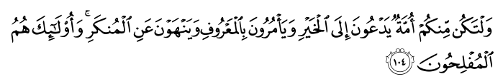](http://corpus.quran.com/wordbyword.jsp?chapter=3&verse=104#(3:104:1))

***Let there be from you a community; inviting to goodness and prosperity; mastering human excellence; rejecting the influences that harm human nature. Those, they will be the successful. (Al-Quran 3:104)***

There are many interconnected causes of crime. They are linked to poverty, unemployment and lack of economic opportunity, low education attainment, unstable families, fatherless homes, addictive and self-destructive behaviors, and negative cultural influences. Crime and criminal behavior has a debilitating impact on individuals, families, and the community. As a result, African Americans must be empowered and self-powered to address these factors that contribute to this debilitation.

Today, more than ever before, the critical institutions of marriage and family life; culture; community economics; and education must be addressed. These institutions form the foundation for the collective human life, they also nurture, guide, and develop our collective life. Muslim Americans of African descent have had an eighty four year history of promoting strong family life, creating cultural paradigms that encourage the best moral and character building traditions of Muslim and American life. This history stresses community based economics, self-reliance, wealth and job creation, and educational achievement designed to liberate and empower the human being. We join others in continuing to promote these values and other human qualities that are the foundation of overcoming the dynamics that are handicapping too many African American communities.

We urge Muslim Americans of African descent to build upon our unique history, experience and knowledge to increase and expand efforts to work with others to improve African American community life.

it.

Today, the communities in which we live are in crisis. People of faith, consciousness, and good-will cannot sit and wait for these problems to resolve themselves. We also cannot wait for other interests, no matter how well meaning, to do for us what we have the G-d given ability and special qualifications to do for ourselves.

In light of the daunting challenges facing the African American community, the Conveners of Imams Associated with the Community of Imam W. Deen Mohammed call upon and encourage all capable members of the African American community to expand our current efforts to meet the sacred obligation of creating, developing, exemplifying, and sharing the best examples of community life for all human beings. We also call upon our entire American family, law enforcement included, to strive hard to protect and secure all of our communities in the face of tremendous challenges, while maintaining and exemplifying those ideals, principles, and values that make America the best place in the world for all people, regardless of ethnicity, religion, income or social status.

**Imam Bashir Ali,**

**National Convener of Imams**

**On Behalf of the Conveners of Imams**